Project 2 DAY 3 Task.pdf
— Explained (Beginner to Interview Level)
This task is about Exploratory Data Analysis (EDA). EDA means examining a dataset to understand its structure, find patterns, detect missing data, and summarize it using statistics and charts.
DAY 3 Task.pdf
What you need to calculate
1. Number of jobs
Count the total rows in the dataset. Each row represents one job posting.
DAY 3 Task.pdf
Python
Run
total_jobs = len(df)
2. Number of unique job titles
Count how many different job titles exist, such as Data Scientist, Java Developer, and QA Engineer.
DAY 3 Task.pdf
Python
Run
df["job_title"].nunique()
3. Most common job roles
Find which job title appears most often. This helps identify hiring trends.
DAY 3 Task.pdf
Python
Run
df["job_title"].value_counts().head(10)
4. Jobs by location
Count jobs available in each city or location.
DAY 3 Task.pdf
Python
Run
df["location"].value_counts()
5–7. Description length
Measure the number of characters in each job description, then calculate the average, minimum, and maximum lengths. The task sheet even provides the example below.
DAY 3 Task.pdf
Python
Run
df["description_length"] = df["job_description"].str.len()

avg_len = df["description_length"].mean()
min_len = df["description_length"].min()
max_len = df["description_length"].max()
8. Missing values
Check which columns contain empty or null values. Missing data affects model accuracy and must be handled before machine learning.
DAY 3 Task.pdf
Python
Run
df.isnull().sum()
9. Duplicate records
Detect repeated rows in the dataset. Duplicate records can bias analysis and should usually be removed.
DAY 3 Task.pdf
Python
Run
df.duplicated().sum()
Visualizations to create
The assignment asks for five charts.
DAY 3 Task.pdf
1. Top Job Titles (Bar Chart)
Shows the 10 most frequently posted job titles.
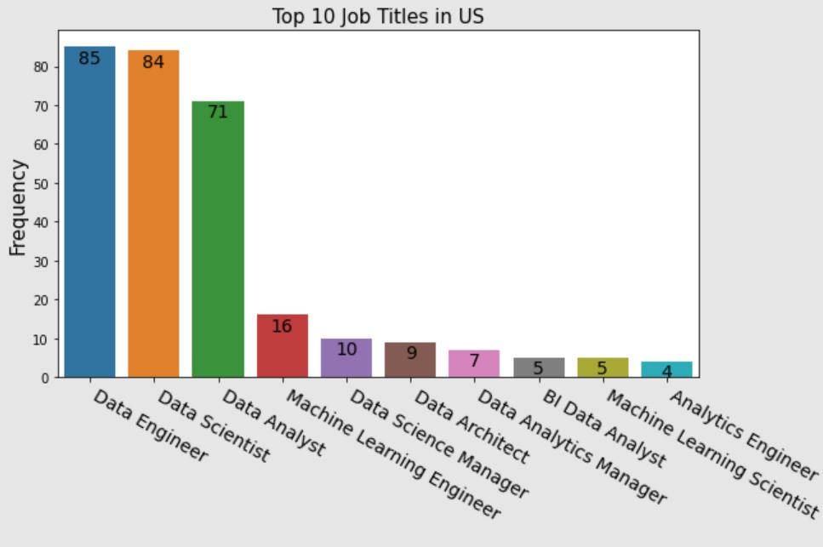
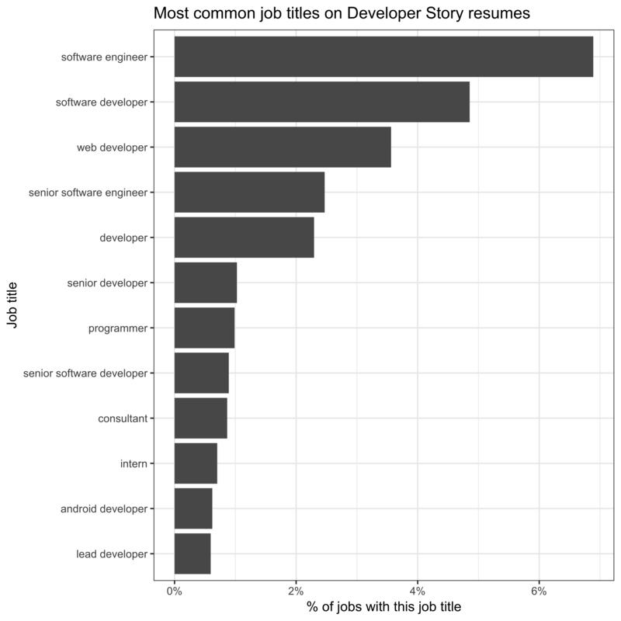
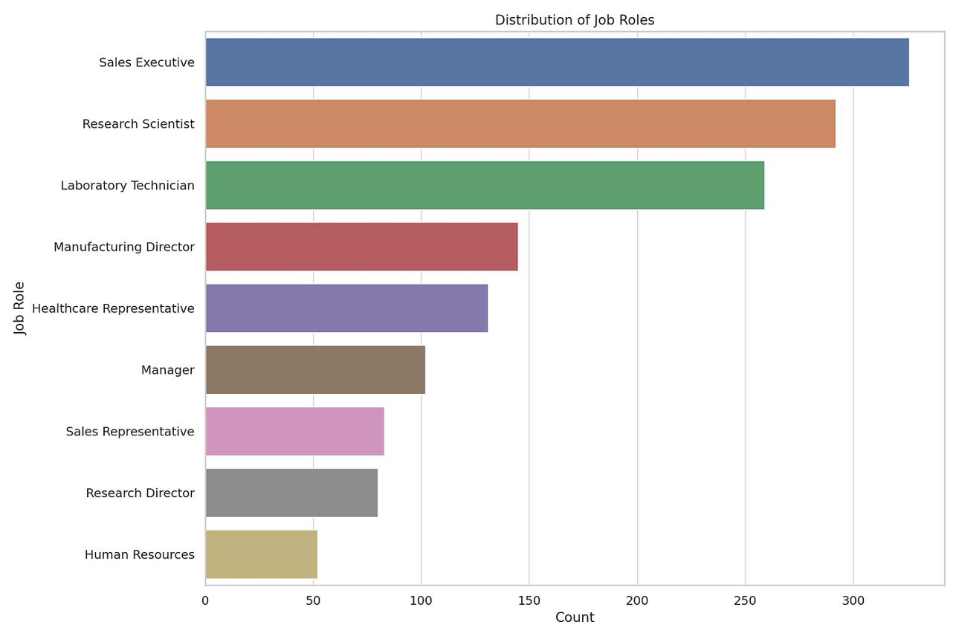
5
Why? It quickly reveals which roles companies hire the most.
2. Jobs by Location (Bar Chart)
Compare hiring across cities.
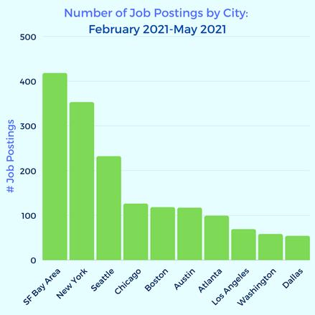
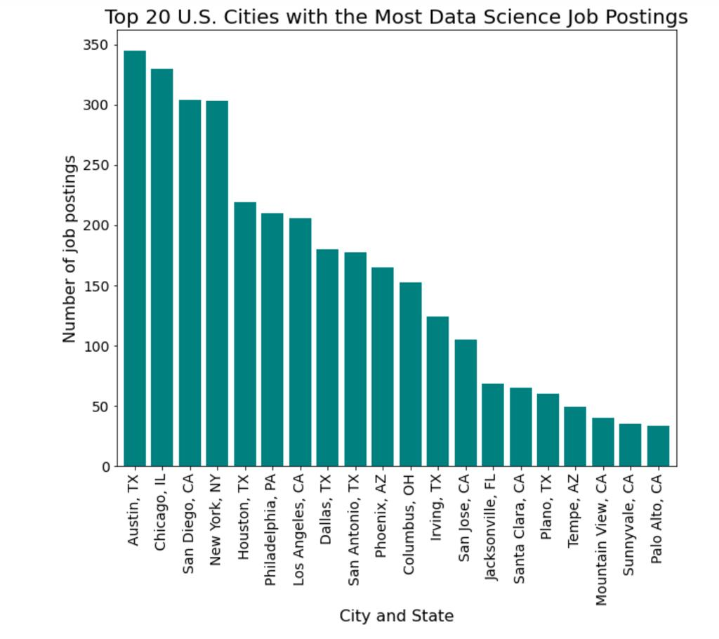
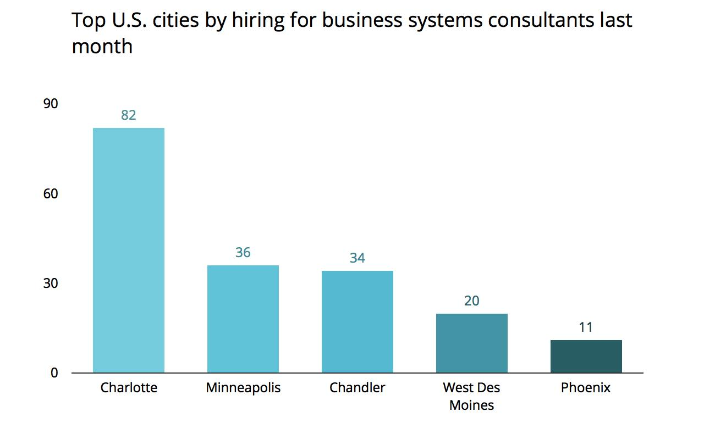
4
Example insight: Pune = 120 jobs, Bangalore = 180 jobs, Hyderabad = 95 jobs.
3. Description Length Distribution (Histogram)
A histogram groups descriptions into length ranges.
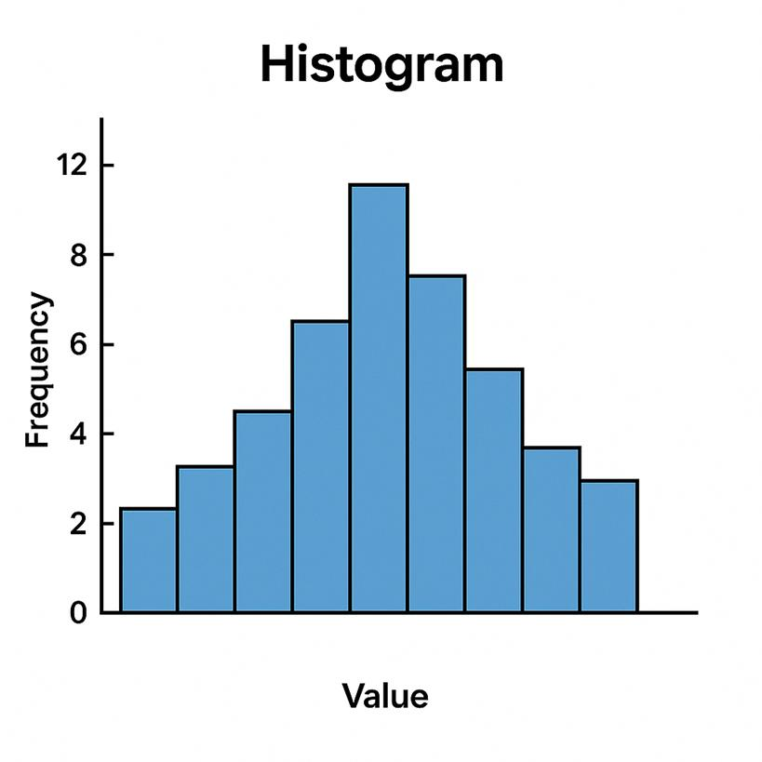
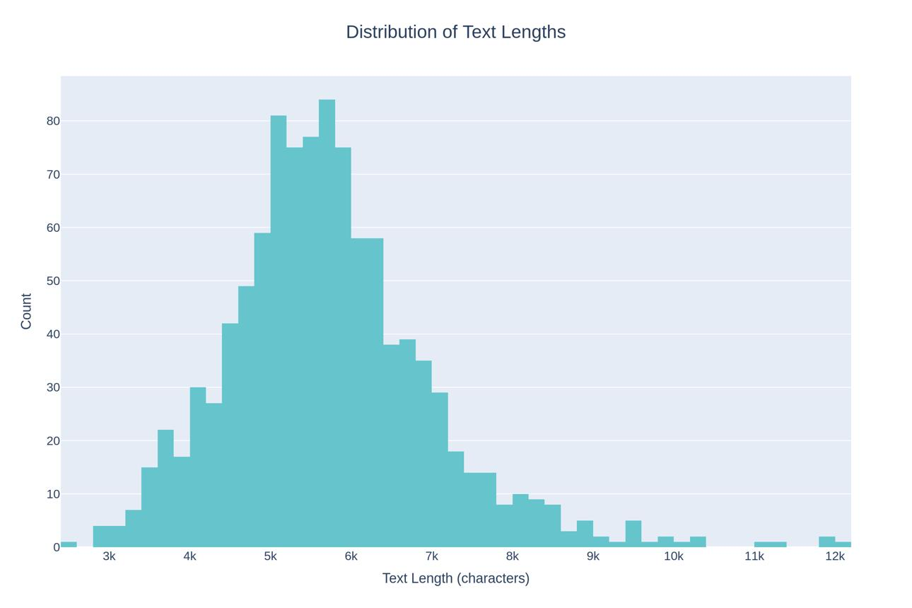
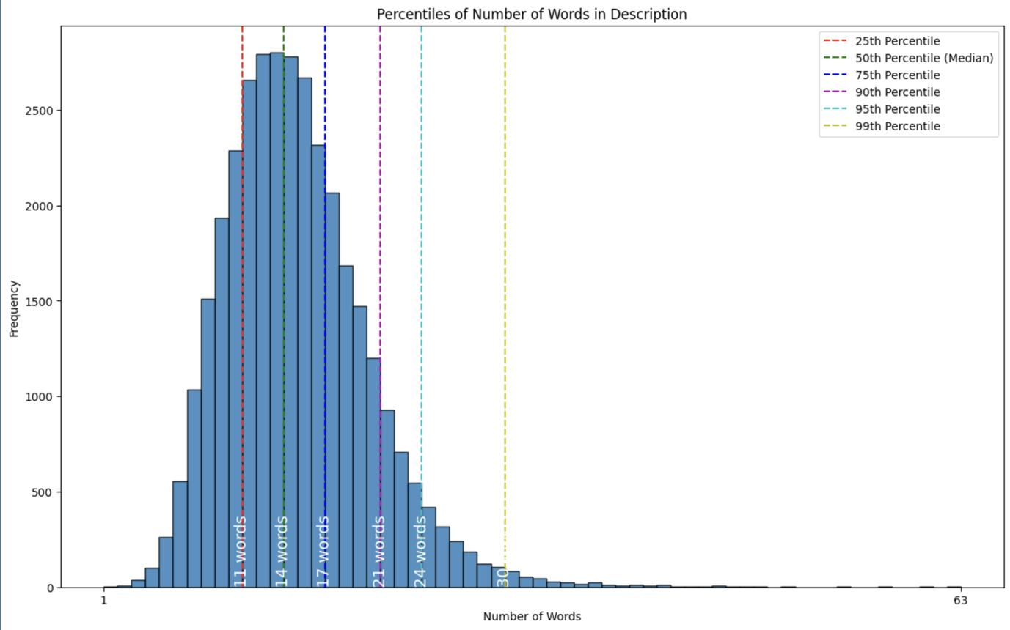
4
Why use a histogram? It shows whether most descriptions are short, medium, or very long.
4. Missing Values (Bar Chart)
Display the number of null values in each column.
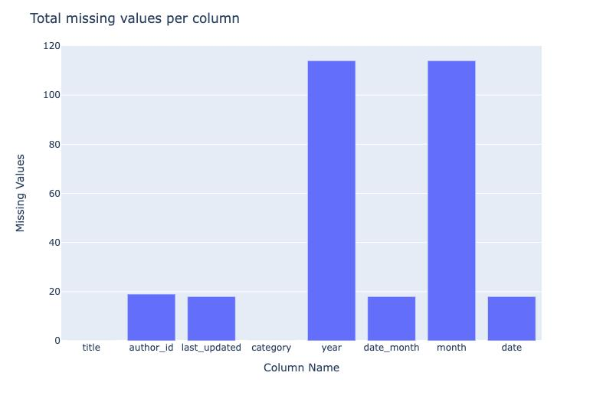
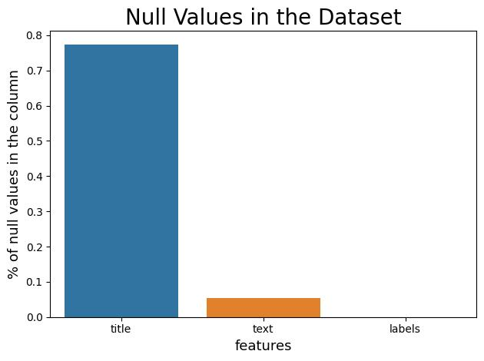
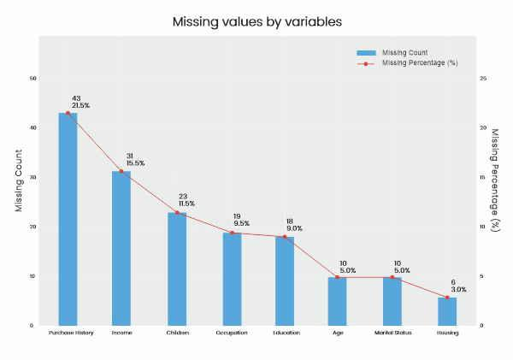
4
This is a data quality visualization.
5. Top Companies (Bar Chart)
Count how many jobs each company posted.
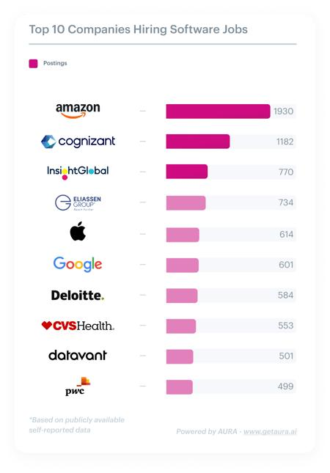
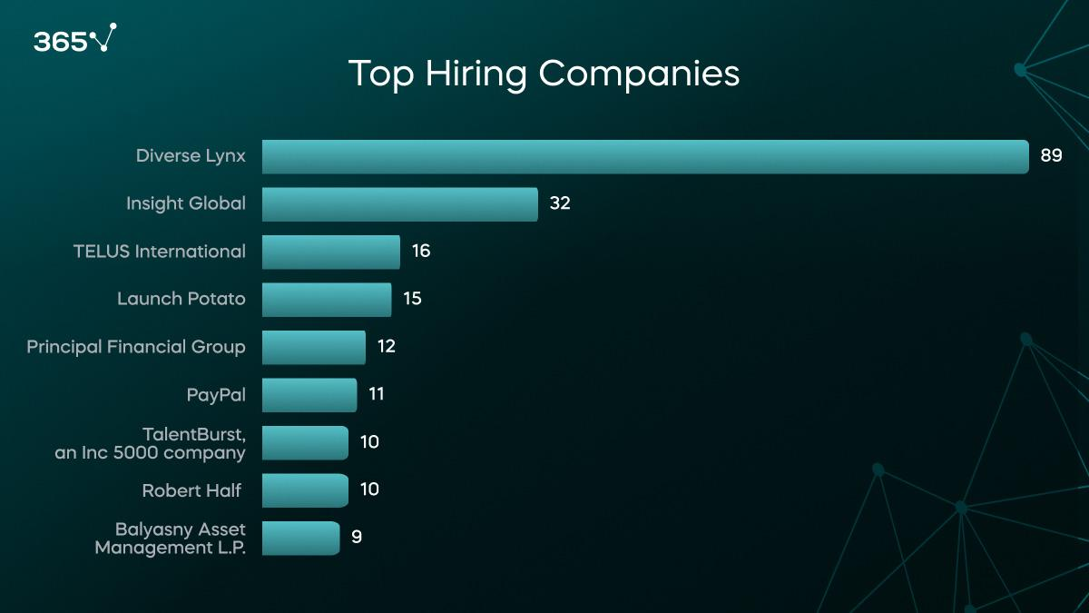
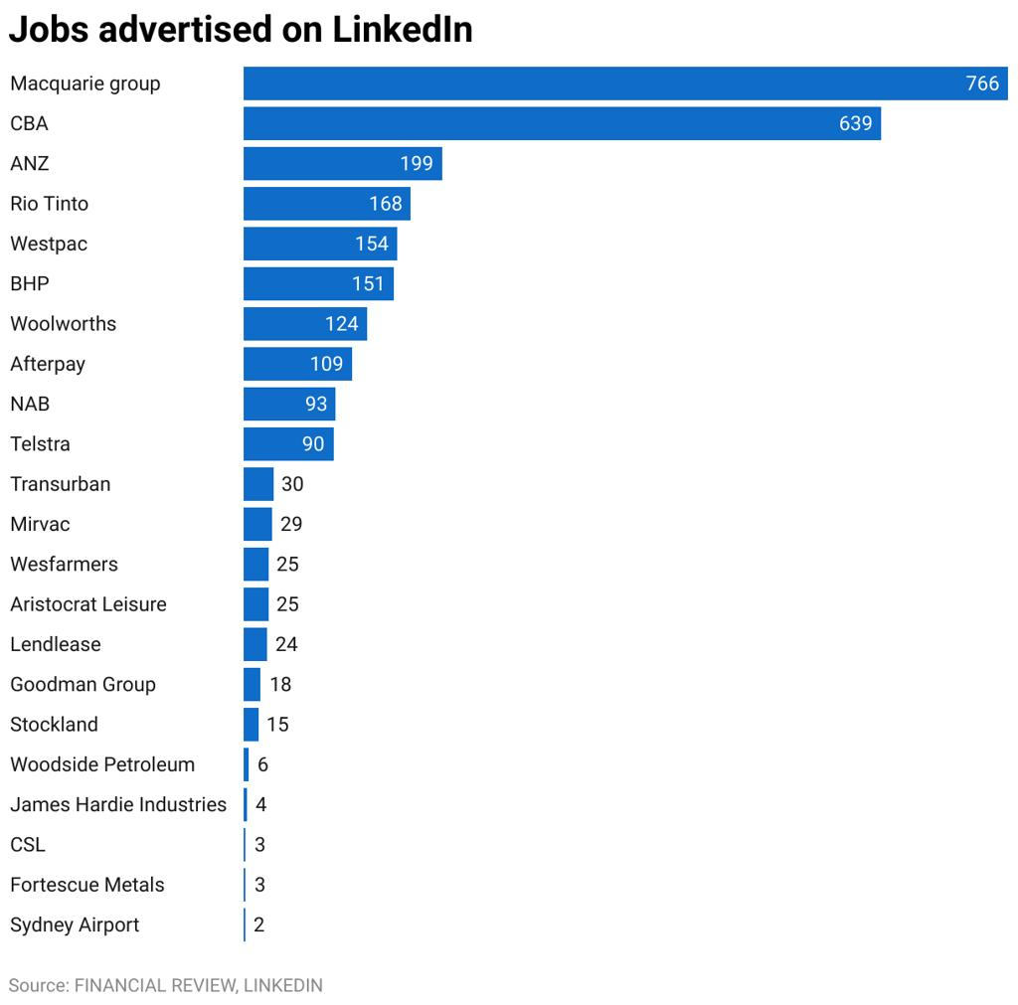
4
This identifies the most active recruiters.
Complete EDA workflow

This is the exact sequence expected in your notebook: import → inspect → clean → analyze → visualize → summarize.
Interview questions & answers
Q1. What is EDA?
EDA (Exploratory Data Analysis) is the process of understanding data using statistics and visualizations before building machine learning models.
Q2. Why do we check missing values?
Missing values reduce data quality and may lead to inaccurate predictions, so they must be identified and handled.
Q3. What is a duplicate record?
A duplicate is an identical row that appears more than once in the dataset.
Q4. Why create description_length?
It converts text into a measurable numeric feature that helps analyze the size of job descriptions.
Deliverable
Your final notebook should be named EDA_Report.ipynb and include all calculations, five visualizations, and a short summary of insights.
DAY 3 Task.pdf
I can also provide the complete Python code divided into Jupyter notebook cells (Cell 1 → Cell 10) exactly matching this Day 3 task.

